**Studio News  
October 2020 Volume 13 Issue 10**

**Liam Scoles, Editor**

**Upcoming Dates:**

October 31 – Piano Club – Activity – The Haunted House

Each door in the Haunted House is guarded by somebody in a Halloween costume. Work in teams to answer a musical question, and their costume disappears so you can go through the door. Prizes from the prize box go to any team who gets out the front door without missing any questions!

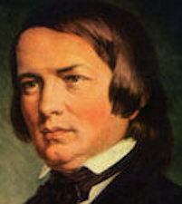

**September Featured Composer on Website**

**(bethspianostudio.com)  
Robert Schumann**

To earn a Schumann Trading Card, tell Beth the featured composer name, musical era, an interesting fact, and your favorite piece by that composer!



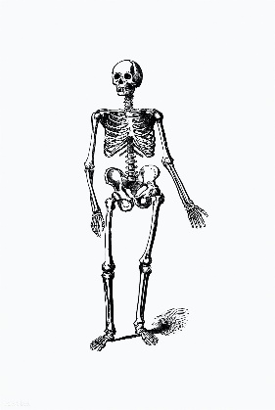

**Joke Corner**

What instrument do skeletons play?

*The trom-BONE!*

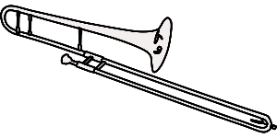

Welcome, new student,

Angelita

**Have you started a Halloween piece yet?**

**Would you like to write something or draw a picture for the “Studio News”?**

**Ask Beth if you need help!**